Bayside Beat

Go to your **unit 28 user area** and create a folder called **Bayside**

Inside this folder create **2** more folders called

* images
* css

From Moodle, download the image called **skyline.jpg** and save it in the images folder

Open sublime text and then open this folder called **Bayside**

Create a new file and save it as **index.html** (make sure it is outside the images folder)

This should look like the following:

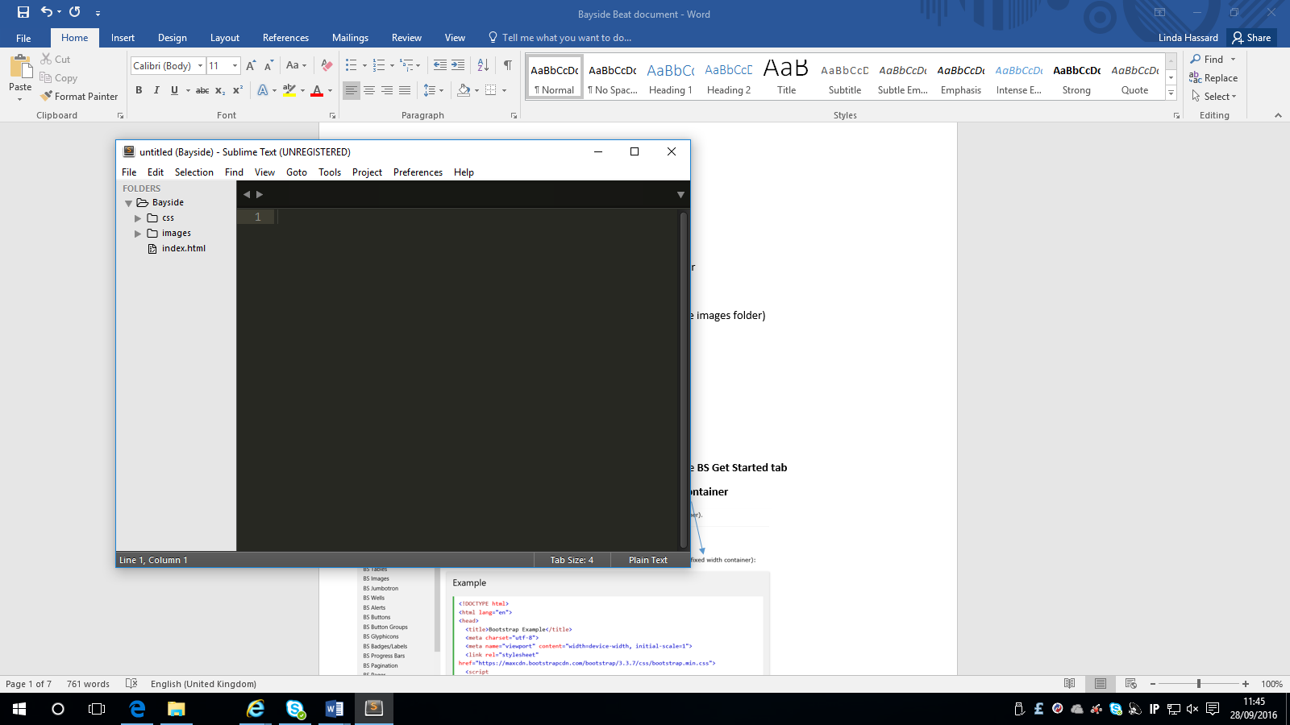

When you click on the images folder it should display the skyline.jpg image

**Creating the basic structure**

Open W3schools and select the **Bootstrap tutorial** and then select the **BS** **Get Started tab** and copy the code for **responsive fixed width container**

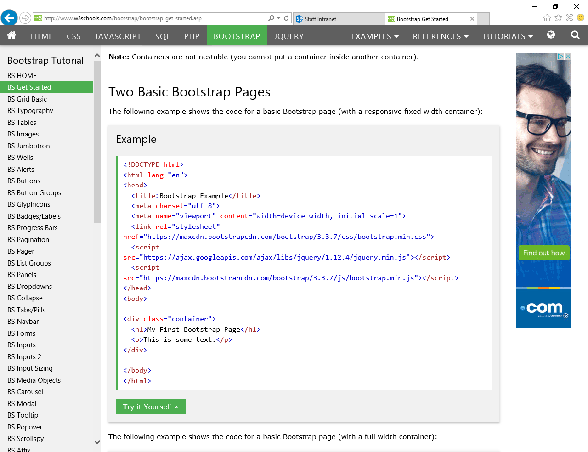

Paste this into your index page and it should look like the following:

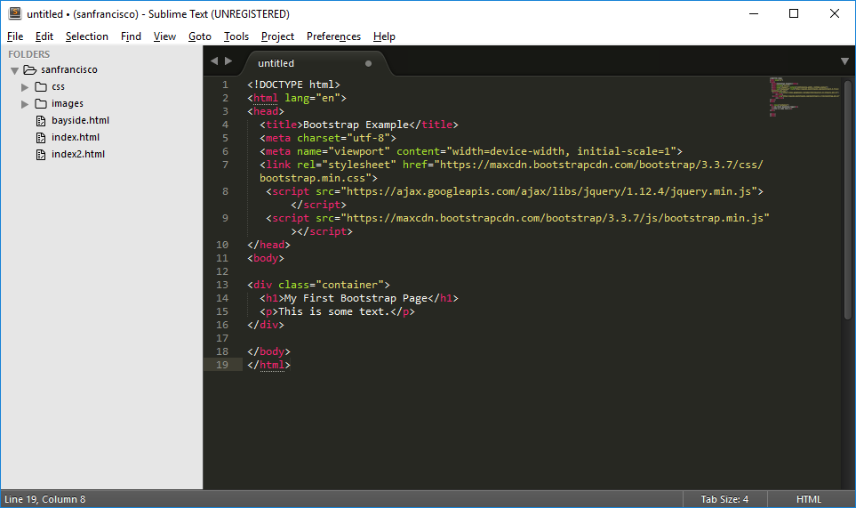

Within the code, make the following changes:

* Change the title to Bayside Beat
* Change the h1 to Bayside Beat
* Delete the paragraph tag
* Save the page again and open in browser

**Adding a Navigation bar**

Go back to w3 schools and select the BS Navbar. Highlight the text as shown below. Make sure that you just highlight the code between the nav tags

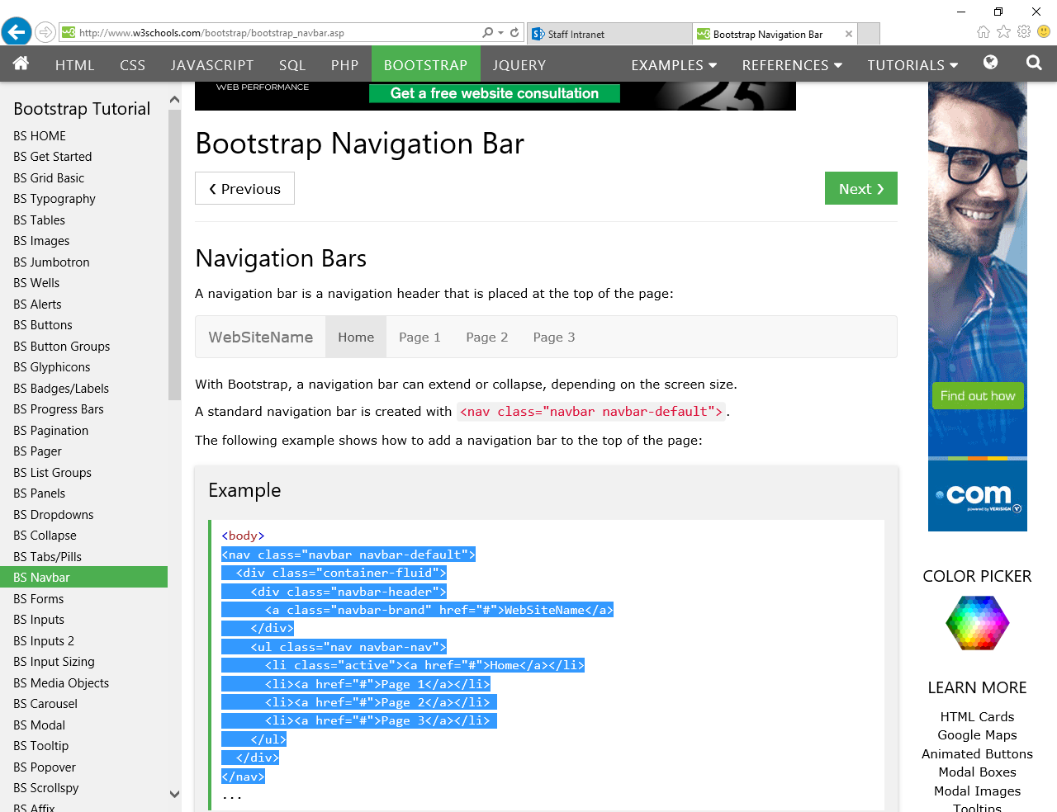

Paste this code directly after the h1 tag

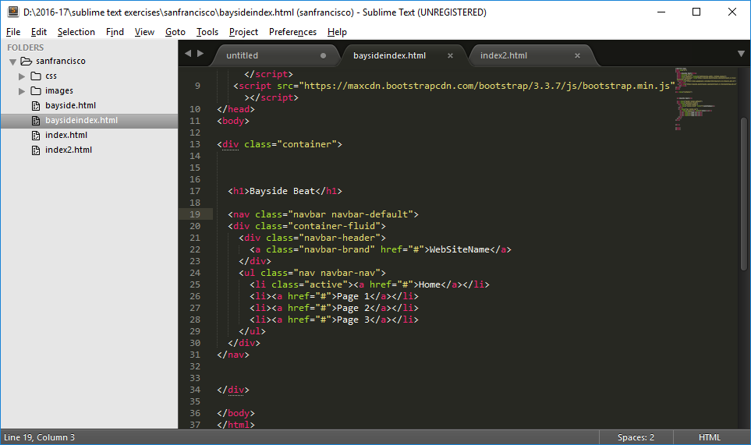

and open in the browser and it should look like this:

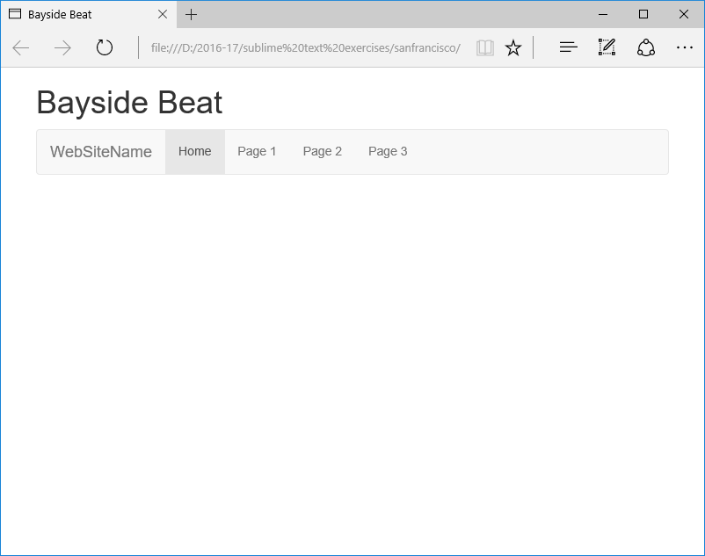

Find the following code:



and replace **WebSiteName** with **Bayside**

Find the following code:



and replace:

* Page 1 with Sightseeing
* Page 2 with Eating Out
* Page 3 with Contact Us

Open in the browser and it should look like this:

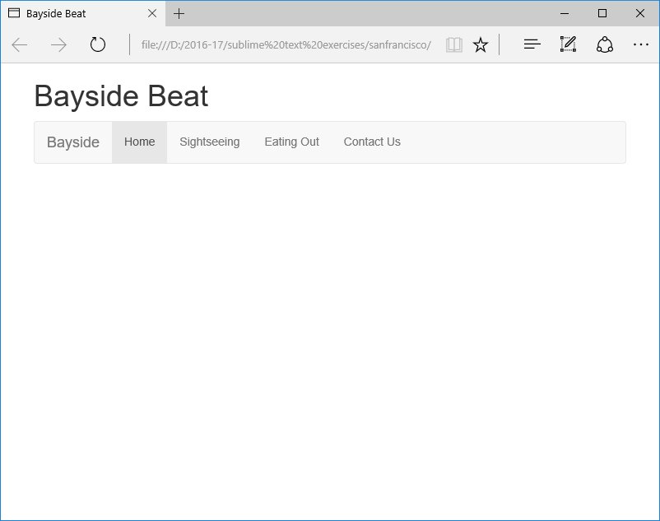

**Adding an image**

Copy the following code and add it after the closing nav tag

<img class="img-responsive" src="images/skyline.jpg" alt="Skyline">

Open in browser and it should look like the following:

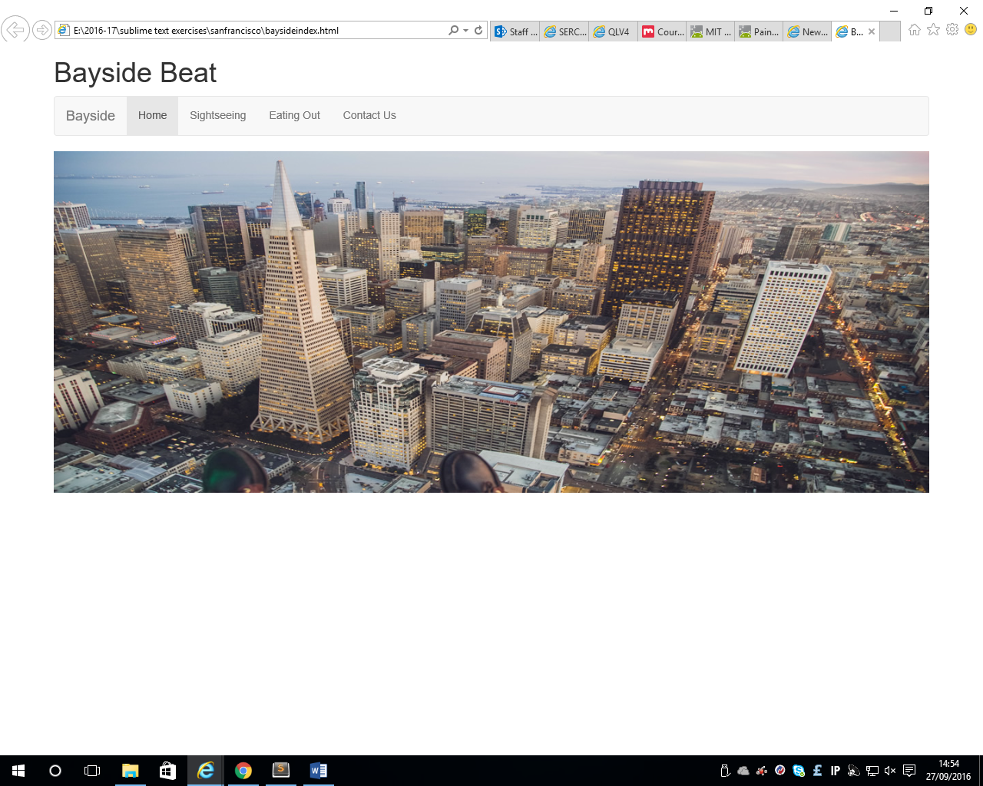

**Adding more layout**

In W3schools select the following tab and copy the code from this example

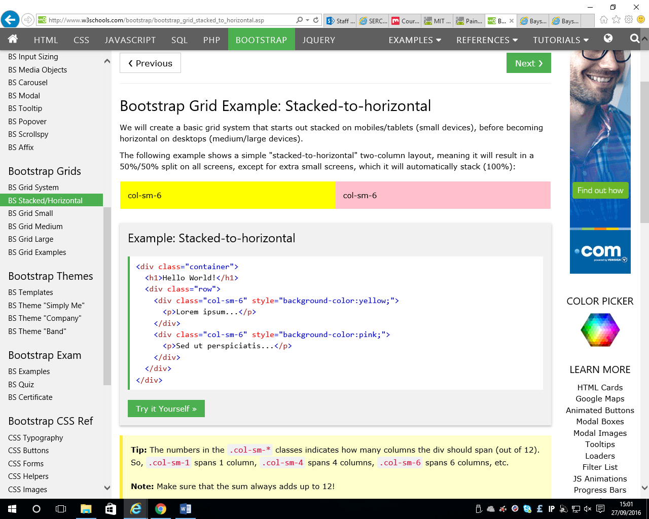

and paste this after the image and before the end of the overall container tag. Save the web page and open in the browser

You will now change some of the code:

Remove the style background colour from both columns

Remove the h1 tag



Before the paragraph tag in the second column, add a heading 3 with the text Cable Car Tips

Before the paragraph tag in the first column, add a heading 3 with the text Riding the Cable Cars

Now ready to add the text into the 2 columns

In the first column, copy and paste the following text between the paragraph tag



No visit to San Francisco is complete without a ride on the iconic cable cars that climb up the vertiginous hills of the city. Of the twenty-three lines established between 1873 and 1890, three remain: two routes from downtown near Union Square to Fisherman's Wharf, and a third route along California Street.

The cable cars rely on cables running constantly beneath the road’s surface. The driver—or gripman—uses a lever to grip the cable to pull the car and its passengers up the hill. The gripman requires not only great strength, but also great skill. He needs to know where to release the cable to coast over crossing cables and points. The conductor works in close cooperation with the gripman, operating the brake at the rear of the car to prevent it from running out of control on the downward slopes.

Although the cable cars are now mainly a tourist attraction, they’re still used by local commuters to get to and from work. The California Street line is particularly popular among commuters on weekdays.

Ensure that you put in extra paragraph tags so that the text is displayed correctly.

In the second column, copy and paste the following text between the following paragraph tag



A single ride on a cable car costs $6. If you plan to travel around the city, it’s often cheaper to buy a Muni Passport, which gives you unlimited rides on San Francisco’s extensive public transport system, including the cable cars (but not the BART subway system). Even a single-day passport ($14) will save you money if you make a return trip, and stop off to visit Chinatown one way.

There are often long lines at the cable car terminus, particularly on the Powell-Mason and Powell-Hyde routes. If you don’t want to wait, try walking a few stops along the route. The conductor usually leaves a small number of places to pick up passengers on the way. The California Street route is generally less crowded (but not as spectacular).

Again, ensure that you put in extra paragraph tags so that the text is displayed correctly.

Save the web page and open in the browser.

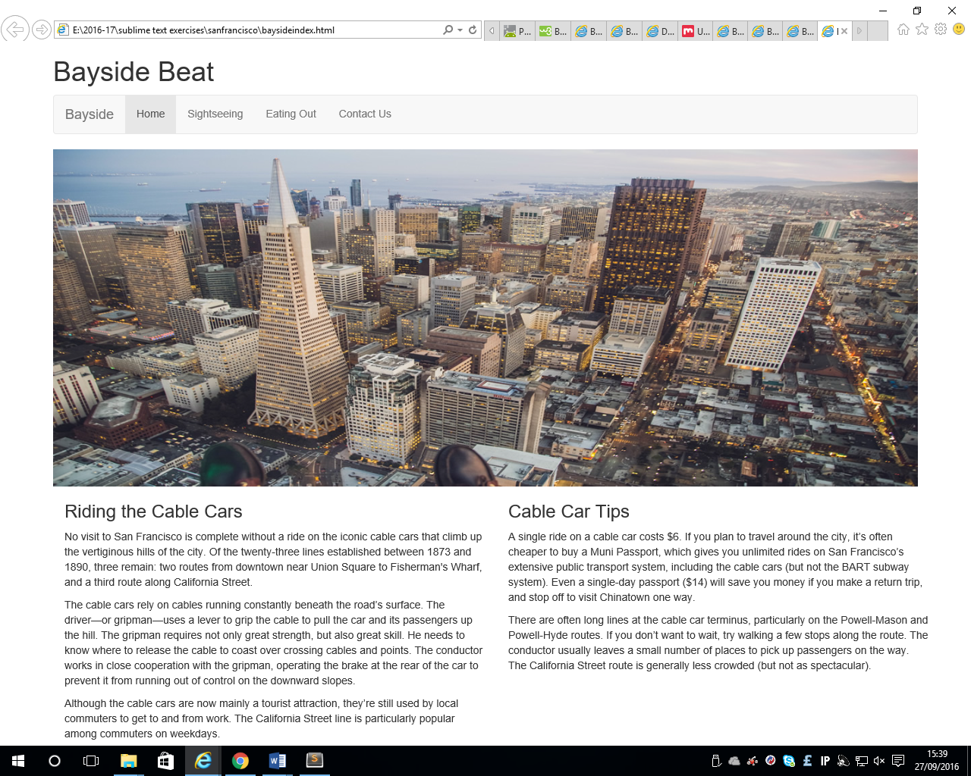

**Adding a footer**

After the code for the columns add the following:

<footer> 2016 Bayside Beat </footer>

Make sure that it is inside the last </div> tag

Your code should look like this:

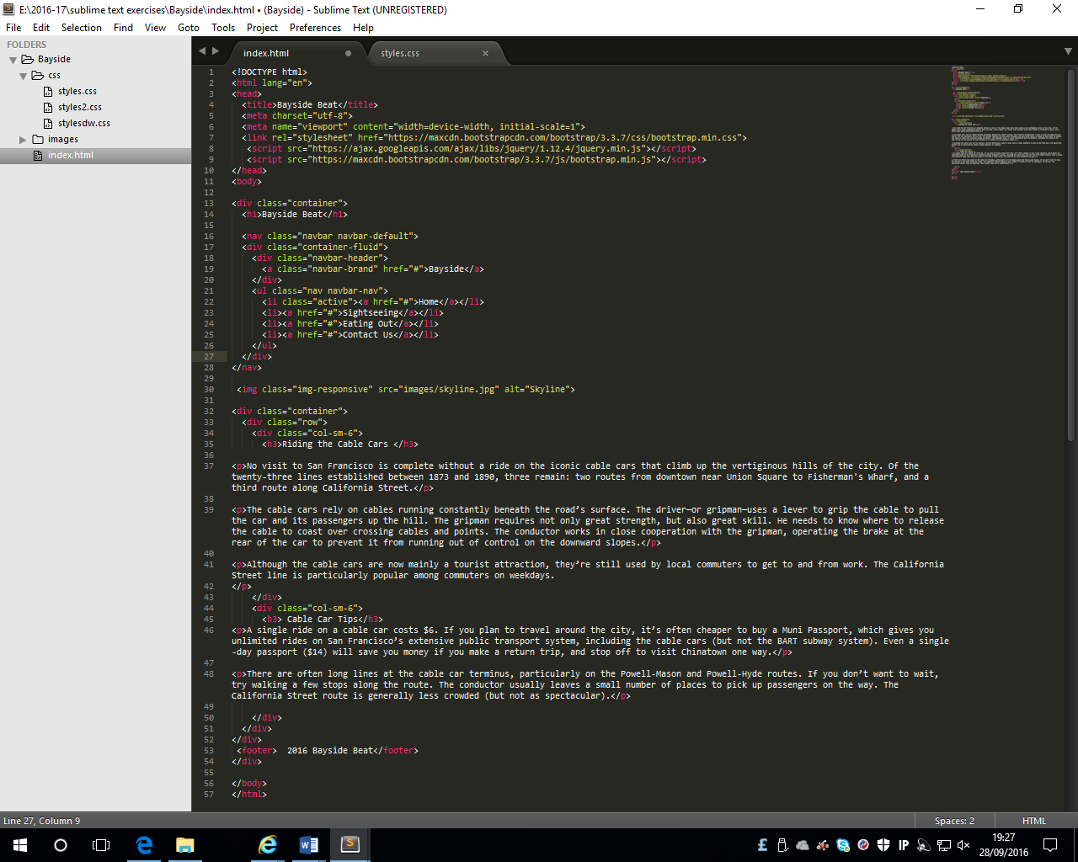

**Adding some comments to the page**

Enter the following comments in the appropriate places in your HTML code:

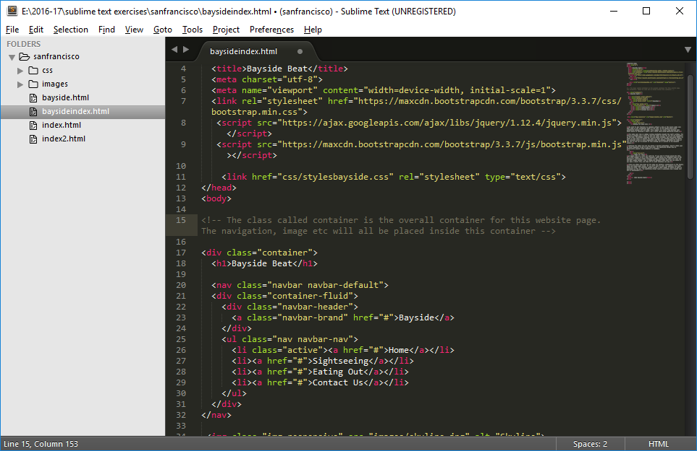

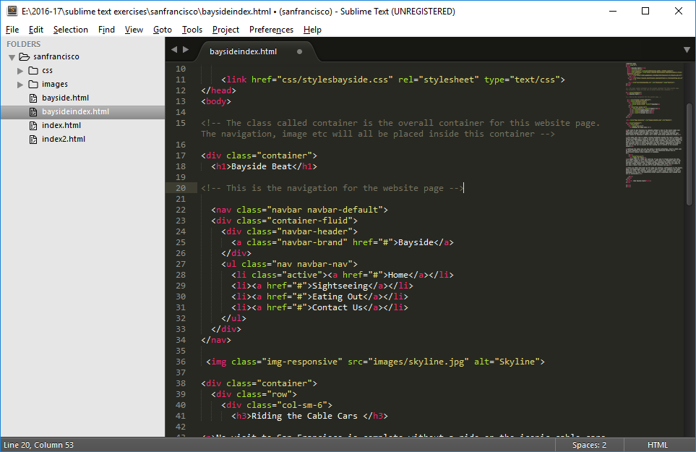

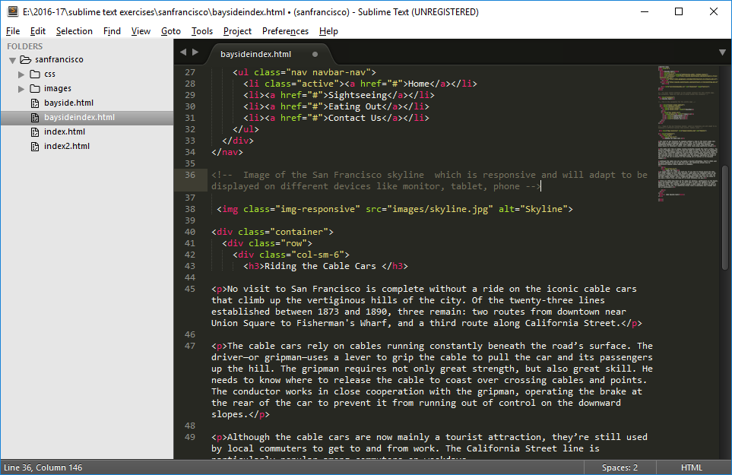

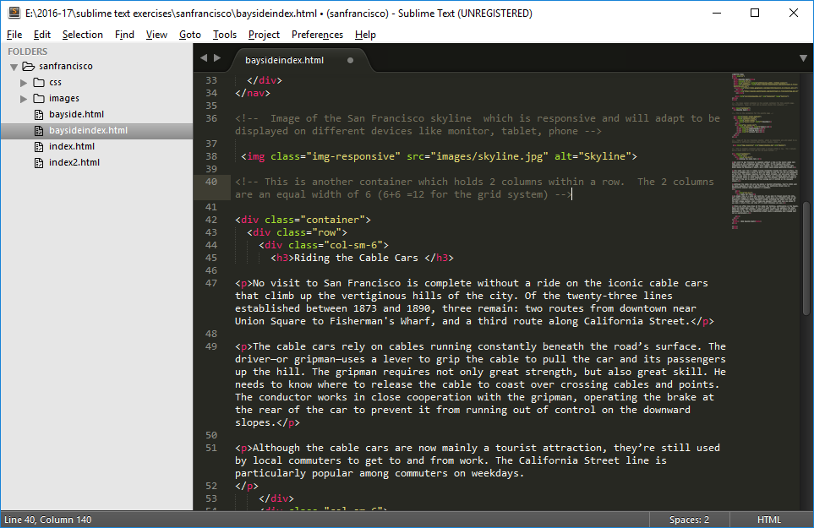

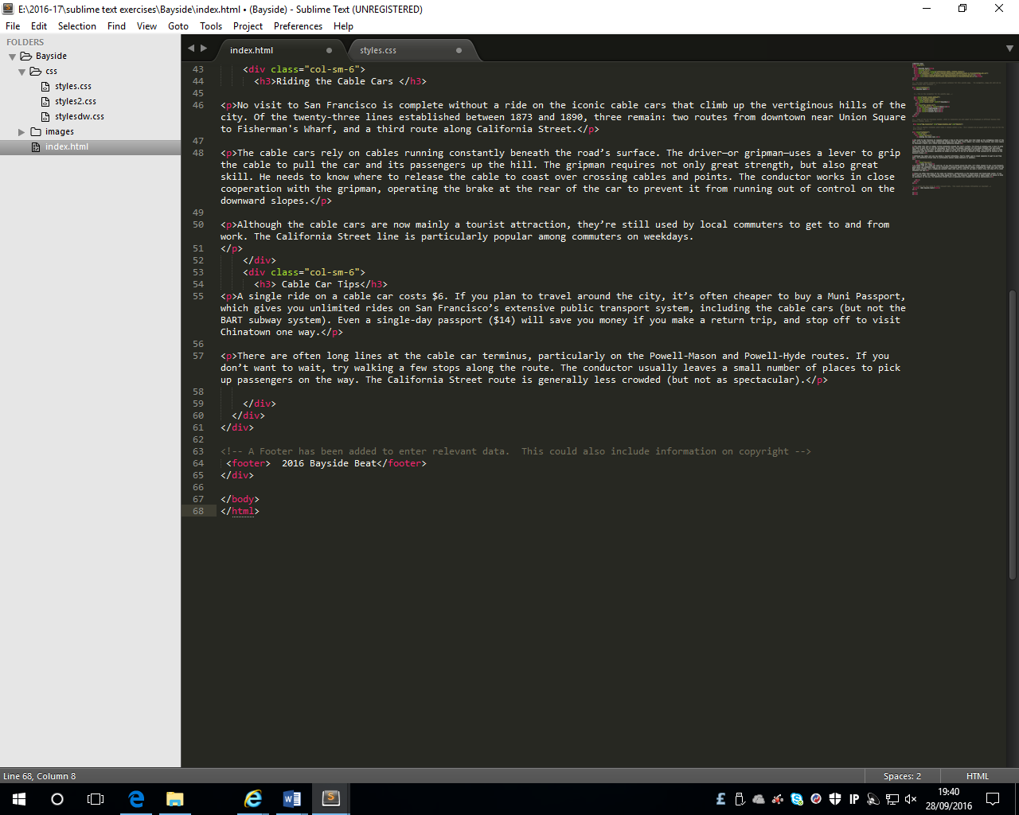

**Adding some styling to the page**

Create a new file and save it as **styles.css**. Make sure that you save it in the **css** folder.

Enter the following comments and code in the styles sheet.

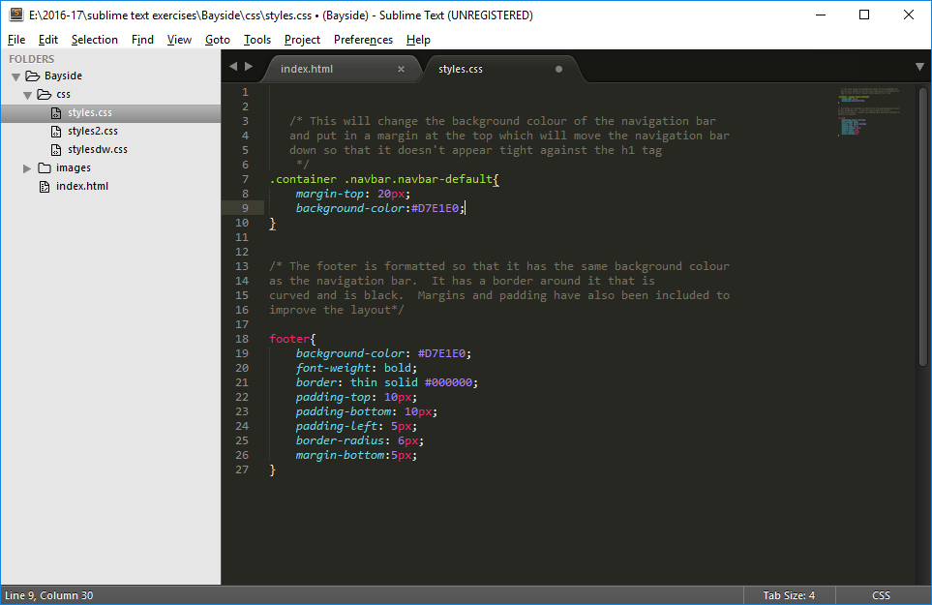

**Linking the style sheet with the html page**

To link this styles.css with the index.html page, enter the following code:

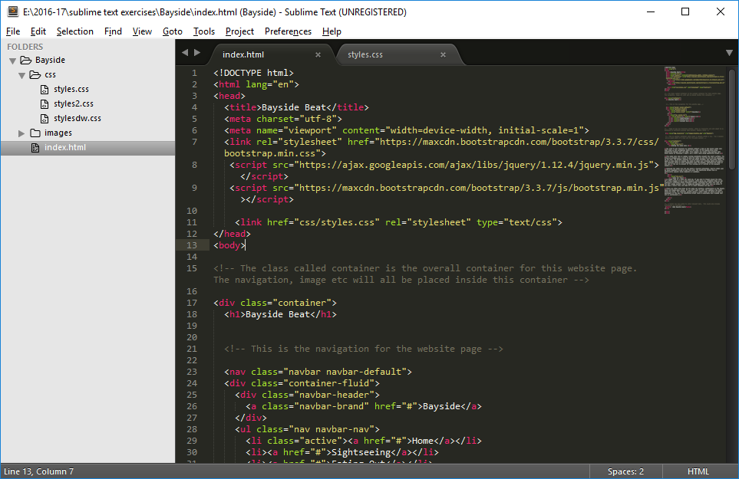

Just before the **</head> tag.**

Make sure that you save both the **index.html page** and the **styles.css page** and **open in browser.**

Your web page should be displayed as follows:

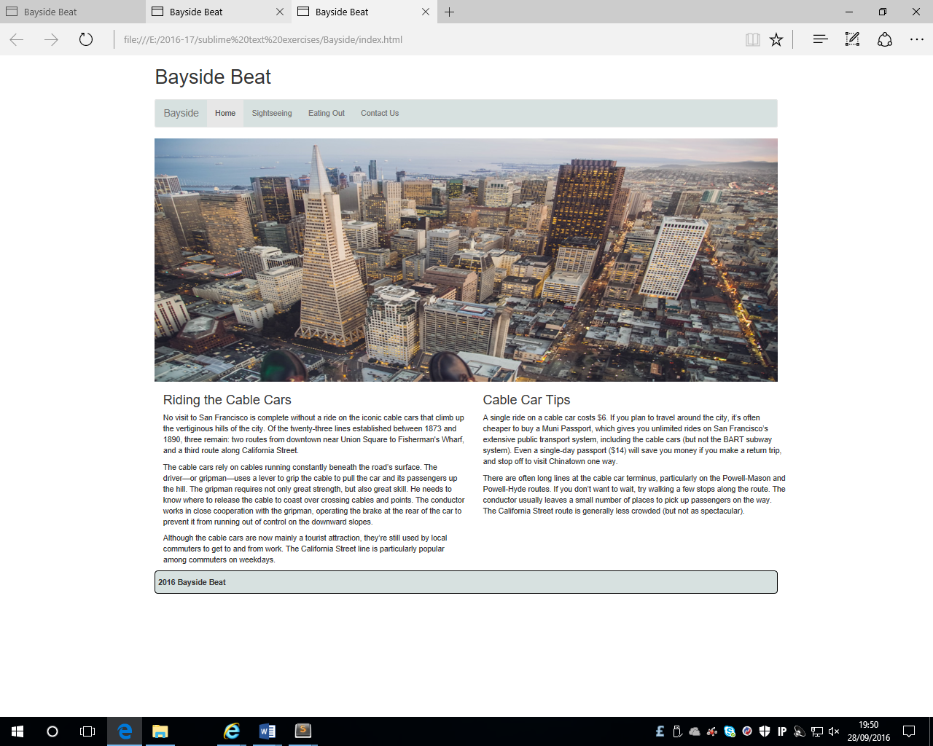

**Adding additional Pages**

Go to the index page and find the following code:

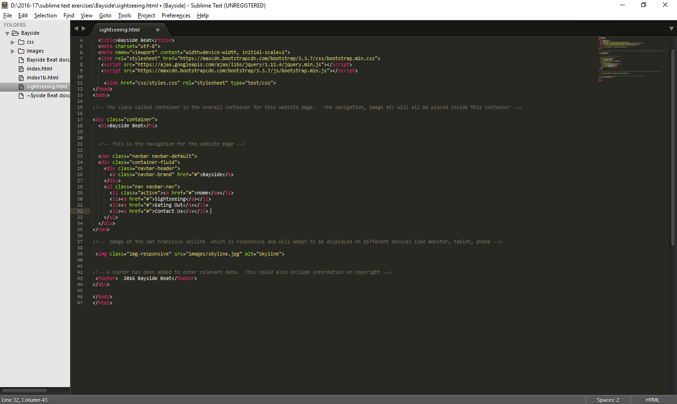

Replace the **#** symbols above with the appropriate page names as follows

* index.html (Bayside option)
* index.html (Home menu option)
* sightseeing.html
* eatingout.html
* contactus.html

So that the code looks like the following:

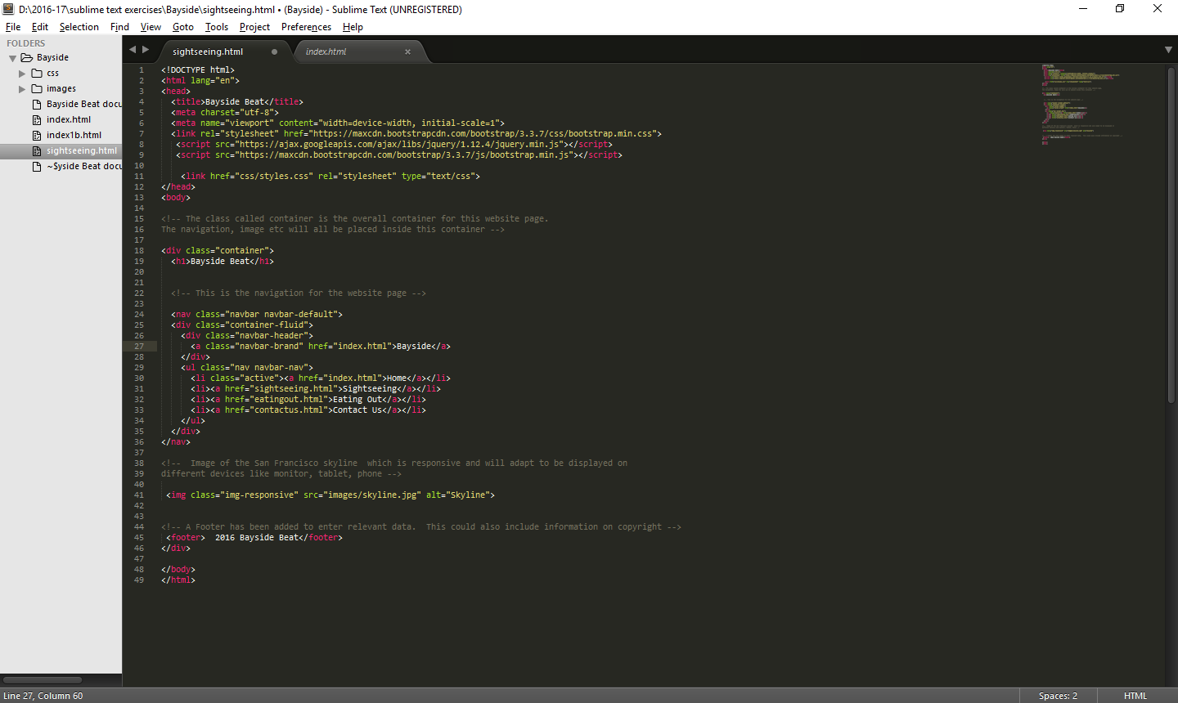

Save the **index.html** page

**Creating the sightseeing.html page**

Make sure that the **index.htm**l page is open. Select save as and save it as **sightseeing.html**.

Make sure that the active page is **sightseeing.html** and delete the layout code and comments for the columns that was entered earlier in the exercise.

This means that all the code entered after the image and before the footer should be deleted.

The code for the page should look like the following:

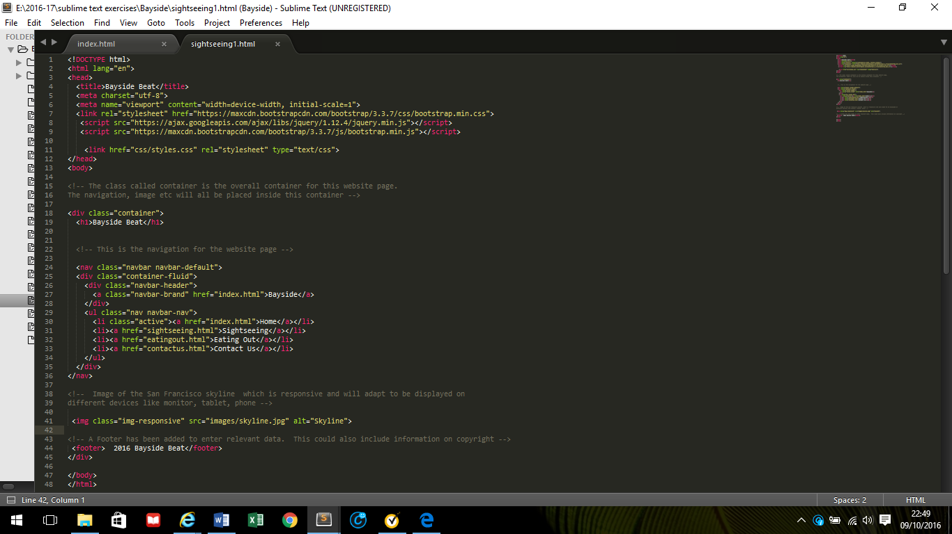

In the navigation, the **active** class now needs to be moved so that the **Sightseeing menu option** is highlighted rather that the Home menu option.

Change the code so that it looks like the following:

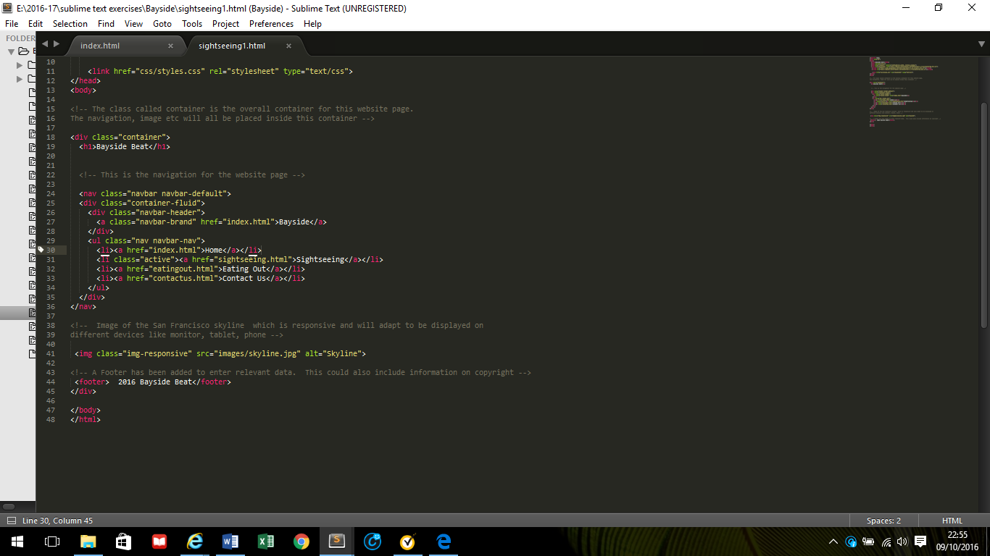

Save the **sightseeing.html** page and open in browser and the page will look like this:

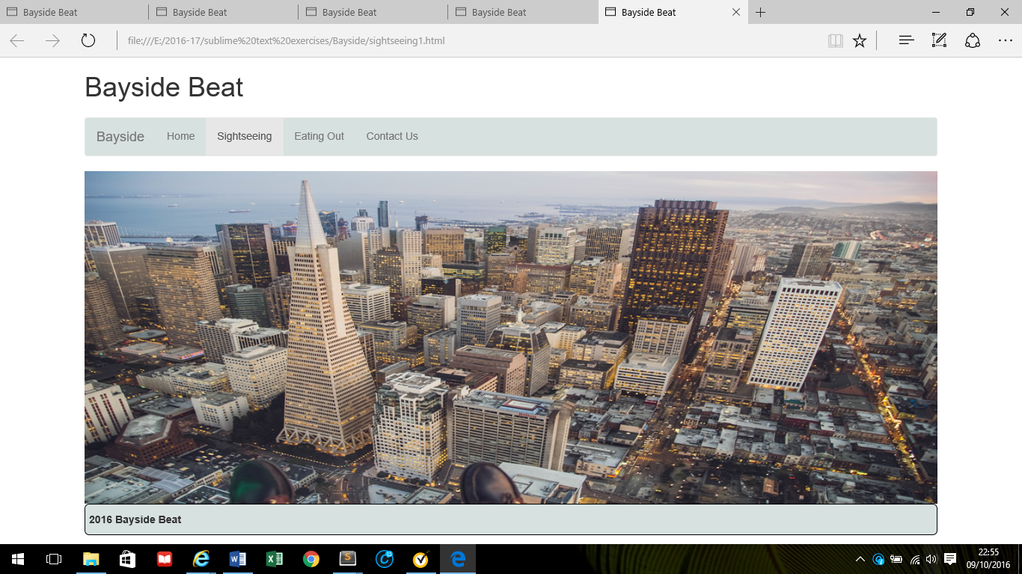

The section between the image and the footer will be different on each page.

**Creating the eatingout.html page and the contactus.html page**

Make sure the sightseeing.html page is open and select the save as option.

* Save the page as **eatingout.html** and then
* Save the page as **contactus.html**

All the pages are now created. Move the active class in the **eatingout.html** and the **contactus.html** as appropriate.

Go to moodle and download the following image files:

* cablecar.jpg
* alcatraz2.jpg
* fishermans_wharf.jpg
* golden_gate.jpg

make sure they are saved in the **images** folder

**Adding layout to the sightseeing.html page**

Make sure that the sightseeing.html page is open and after the code for the **image**, add the following code:

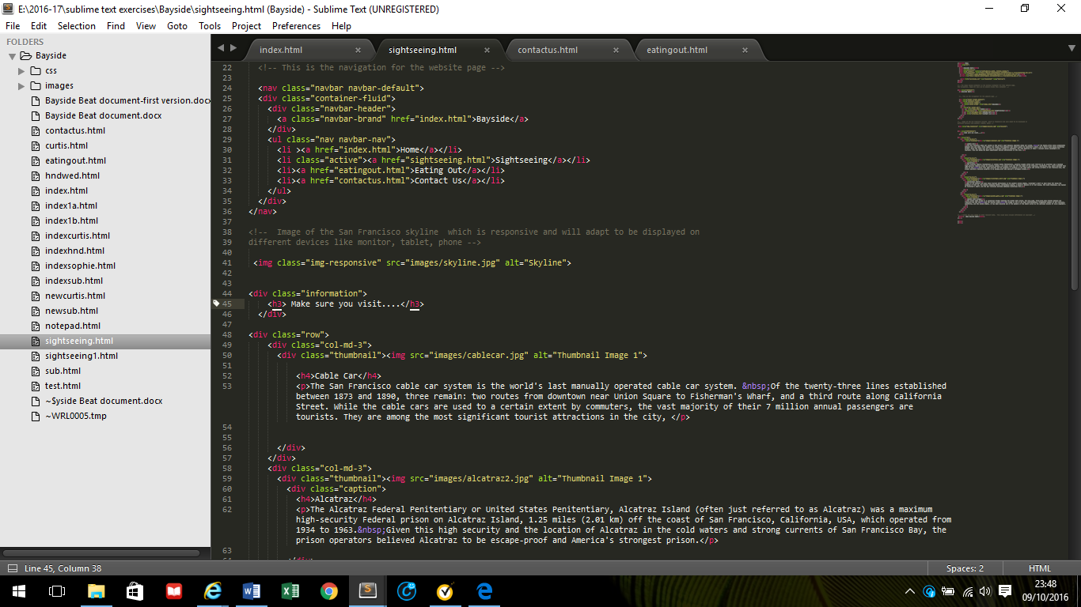

Following this code, add the following comment:

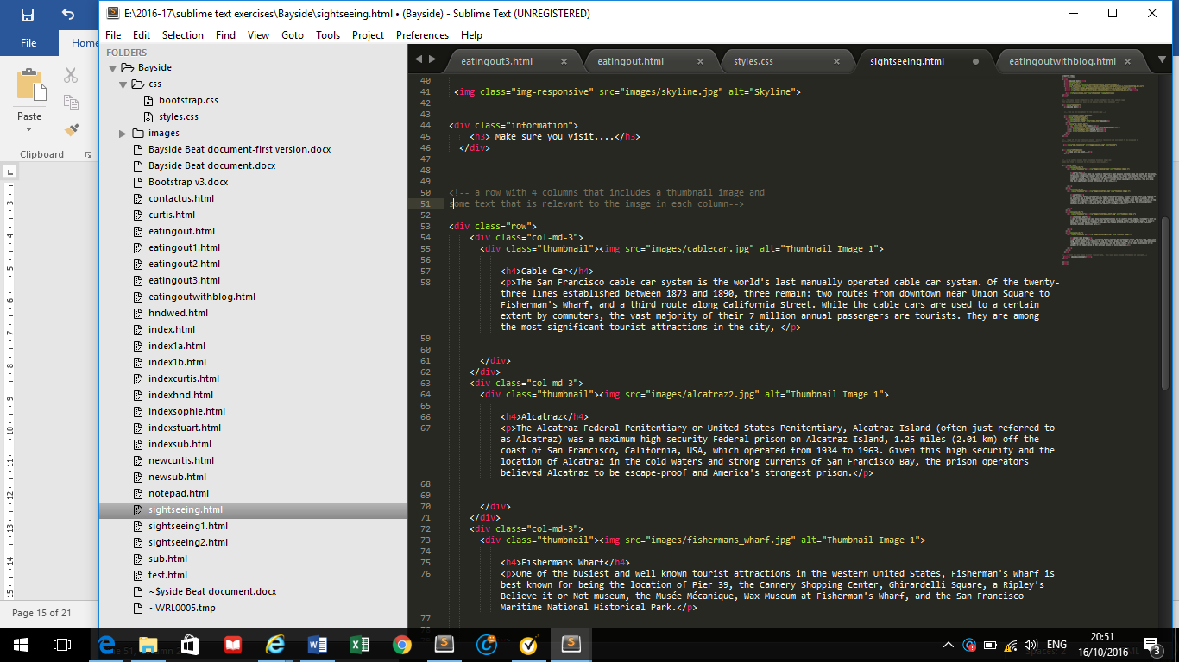

Next, copy and paste the following code after the comment

<div class="row">

<div class="col-md-3">

<div class="thumbnail"><img src="" alt="Thumbnail Image 1">

</div>

</div>

<div class="col-md-3">

<div class="thumbnail"><img src="" alt="Thumbnail Image 1">

</div>

</div>

<div class="col-md-3">

<div class="thumbnail"><img src="" alt="Thumbnail Image 1">

</div>

</div>

<div class="col-md-3">

<div class="thumbnail"><img src="" alt="Thumbnail Image 1">

</div>

</div>

</div>

Four columns have been created each with a class of thumbnail. No images have been added to the page at this stage.

Save the page and preview in the browser

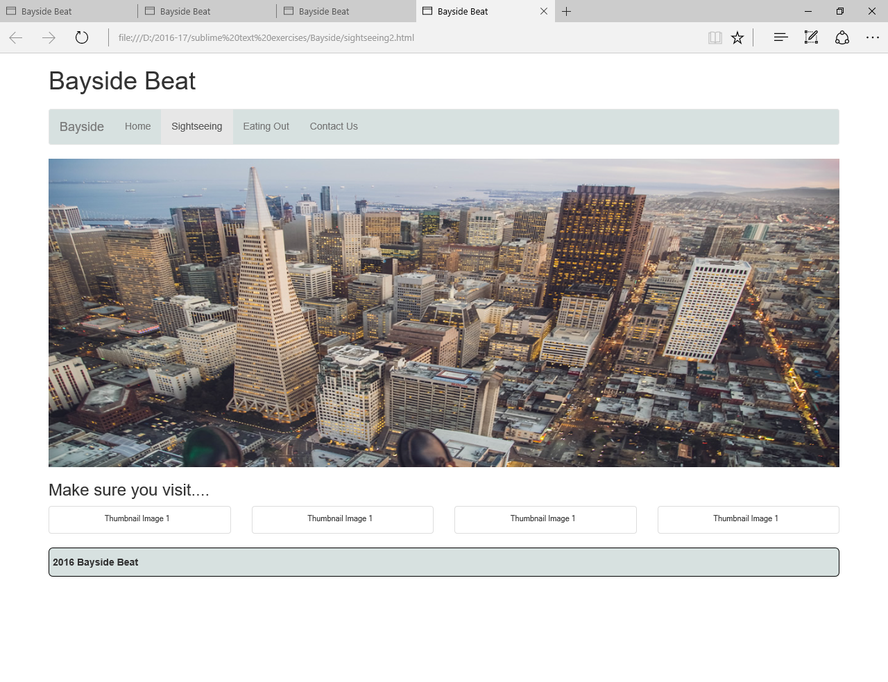

The alt text is displayed as no image has been entered.

Add the following images (remember to include the correct path as the images should be saved in the image folder) in the appropriate places starting with the first column and placing the cable car image as shown below:

<div class="thumbnail"><img src=" " alt="Thumbnail Image 1">

* cablecar.jpg with the alt text of **Cable Car**
* alcatraz2.jpg with the alt text of **Alcatraz**
* fishermans_wharf.jpg with the alt text of **Fisherman’s Wharf**
* golden_gate.jpg with the alt text of **The Golden Gate**

Save the page and open in the browser

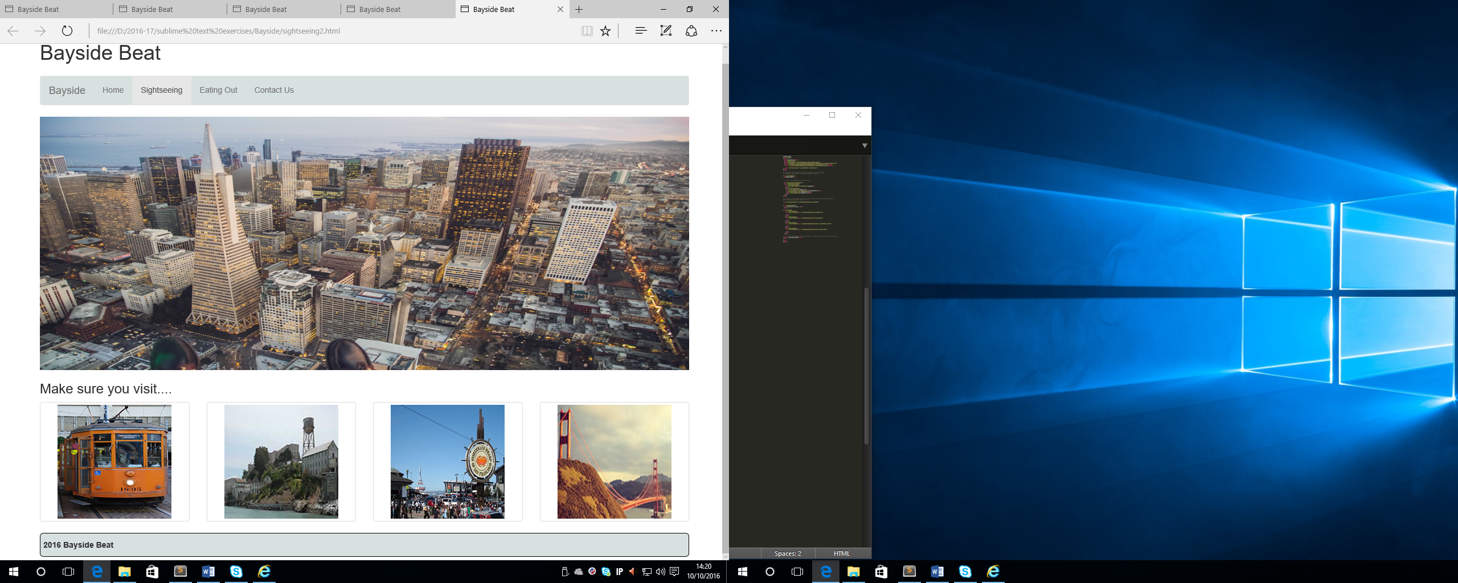

Next is to add some relevant text into the 4 columns

Find the following code for the first column which will already have the cablecar.jpg image

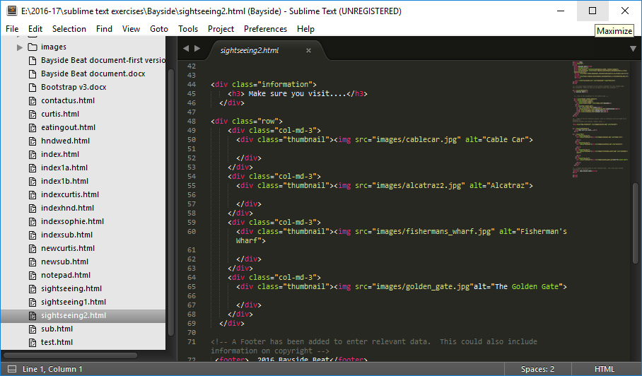

After the code for the image and before the </div> enter the following text:

Cable Car – **heading 4**

The San Francisco cable car system is the world's last manually operated cable car system. Of the twenty-three lines established between 1873 and 1890, three remain: two routes from downtown near Union Square to Fisherman's Wharf, and a third route along California Street. While the cable cars are used to a certain extent by commuters, the vast majority of their 7 million annual passengers are tourists. They are among the most significant tourist attractions in the city. - **paragraph**

Add the following code in the appropriate sections:

Alcatraz– **heading 4**

The Alcatraz Federal Penitentiary or United States Penitentiary, Alcatraz Island (often just referred to as Alcatraz) was a maximum high-security Federal prison on Alcatraz Island, 1.25 miles (2.01 km) off the coast of San Francisco, California, USA, which operated from 1934 to 1963. Given this high security and the location of Alcatraz in the cold waters and strong currents of San Francisco Bay, the prison operators believed Alcatraz to be escape-proof and America's strongest prison. - **paragraph**

Fishermans Wharf– **heading 4**

One of the busiest and well known tourist attractions in the western United States, Fisherman's Wharf is best known for being the location of Pier 39, the Cannery Shopping Center, Ghirardelli Square, a Ripley's Believe it or Not museum, the Musée Mécanique, Wax Museum at Fisherman's Wharf, and the San Francisco Maritime National Historical Park. - **paragraph**

Golden Gate Bridge– **heading 4**

The Golden Gate Bridge is a suspension bridge spanning the Golden Gate strait, the mile-wide, three-mile-long channel between San Francisco Bay and the Pacific Ocean. The bridge is one of the most internationally recognized symbols of San Francisco, California, and the United States. It has been declared one of the Wonders of the Modern World by the American Society of Civil Engineers. – **paragraph**

Save the page and preview in the browser, the page should look like the following:

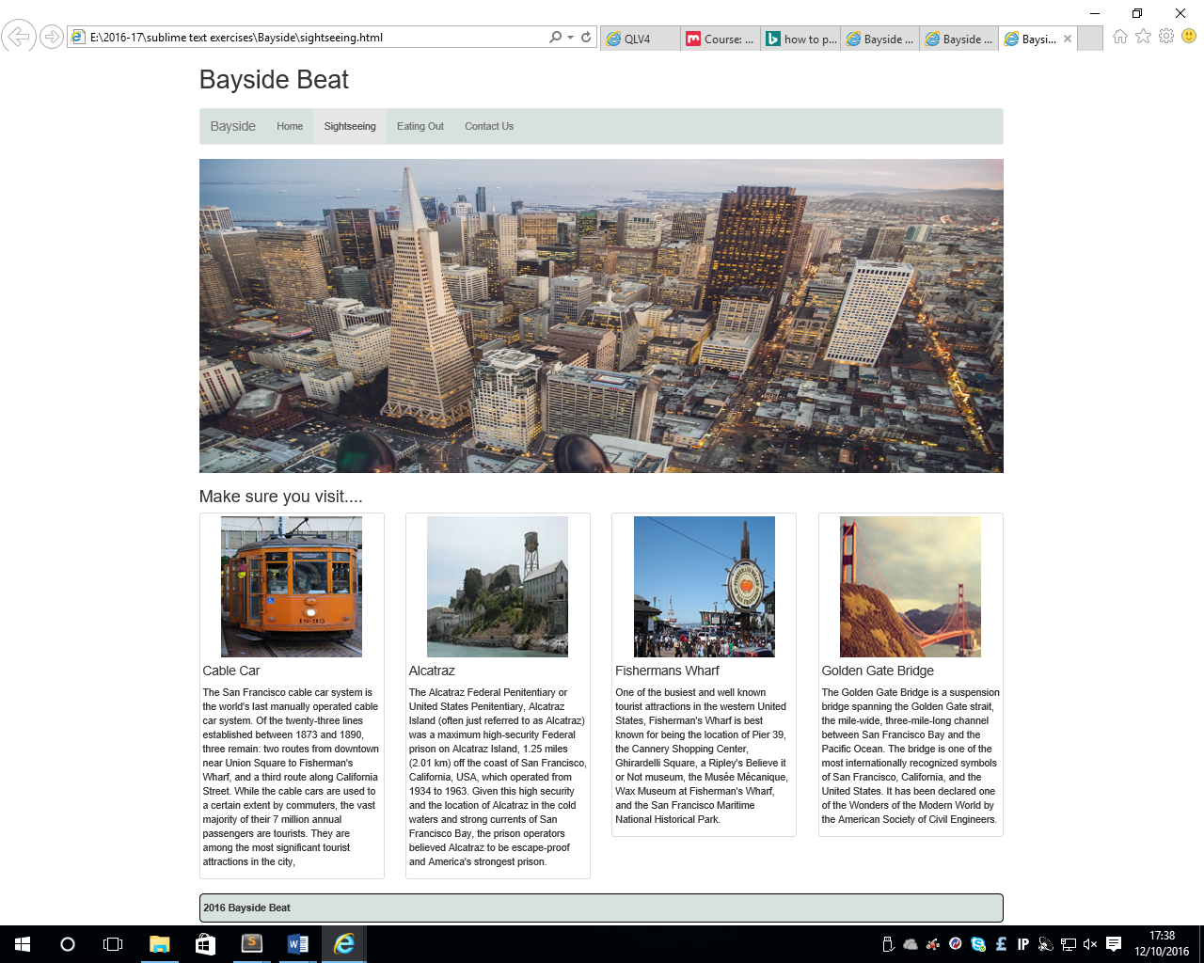

**Adding layout to the eatingout.html page**

Make sure that the sightseeing.html page is open and after the code for the **image**, add the following code:

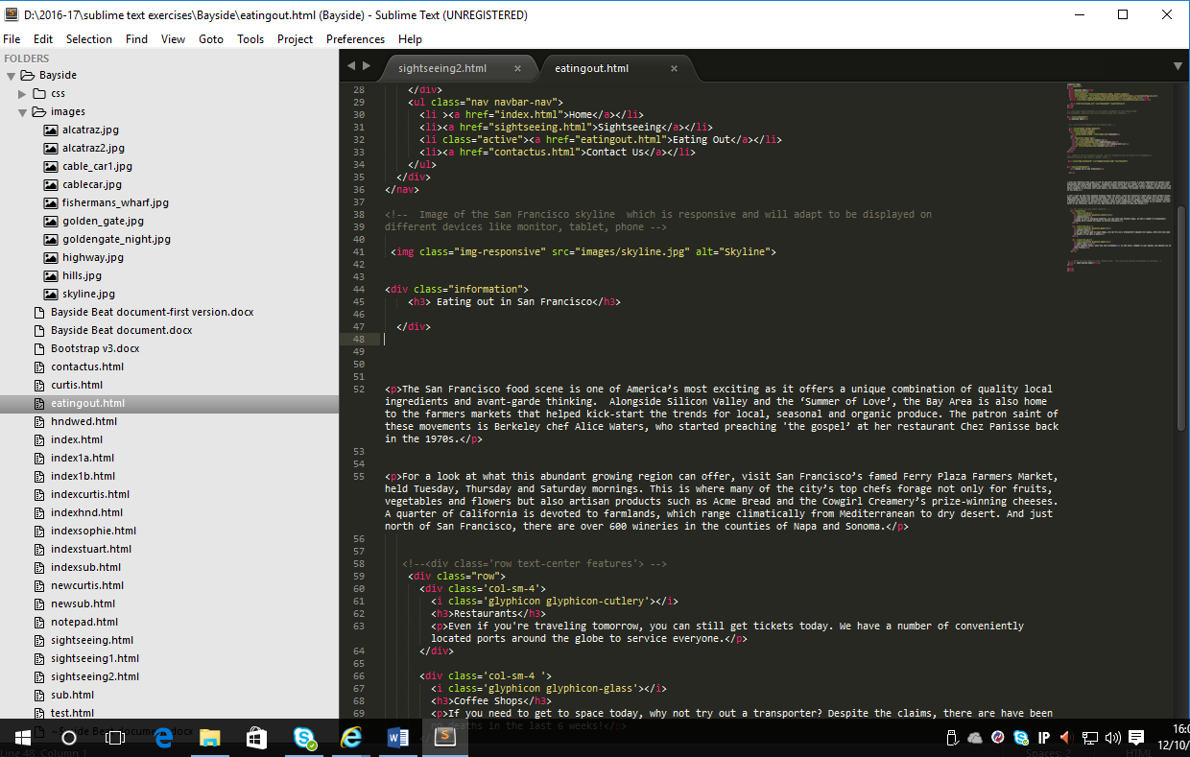

Enter the following 2 paragraphs just before the ending div tag

The San Francisco food scene is one of America’s most exciting as it offers a unique combination of quality local ingredients and avant-garde thinking. Alongside Silicon Valley and the ‘Summer of Love’, the Bay Area is also home to the farmers’ markets that helped kick-start the trends for local, seasonal and organic produce. The patron saint of these movements is Berkeley chef Alice Waters, who started preaching 'the gospel’ at her restaurant Chez Panisse back in the 1970s.

For a look at what this abundant growing region can offer, visit San Francisco’s famed Ferry Plaza Farmers Market, held Tuesday, Thursday and Saturday mornings. This is where many of the city’s top chefs forage not only for fruits, vegetables and flowers but also artisan products such as Acme Bread and the Cowgirl Creamery’s prize-winning cheeses. A quarter of California is devoted to farmlands, which range climatically from Mediterranean to dry desert. And just north of San Francisco, there are over 600 wineries in the counties of Napa and Sonoma.

Make sure that the appropriate paragraph tags are entered. Save and open in the browser.

Next, copy and paste the following code after the code that has just been entered (after the </div> tag)

<div class="row">

<div class='col-sm-4'>

<i class='glyphicon glyphicon-cutlery'></i>

</div>

<div class='col-sm-4 '>

<i class='glyphicon glyphicon-glass'></i>

</div>

<div class='col-sm-4'>

<i class='glyphicon glyphicon-apple'></i>

</div>

</div>

Save the page and open in the browser

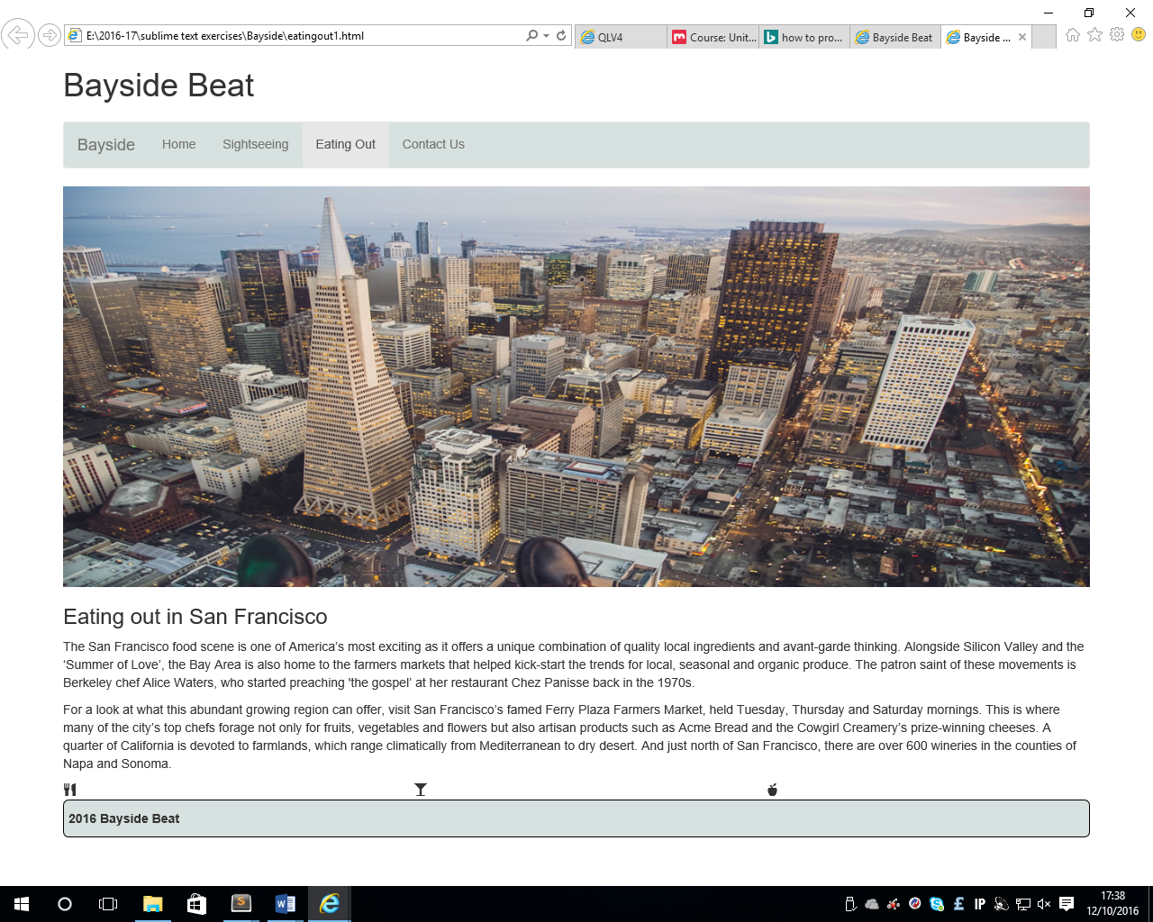

Next is to enter some text immediately after the code for the glyphicon

Restaurants - **heading 3**

100 restaurants, that seems like a lot of restaurants, but in San Francisco that number barely covers the creme de la creme. No other area of the country has a more dynamic scene, and it keeps getting better. -**paragraph**

Coffee Shops- **heading 3**

The best coffee shops and cafés in San Francisco

Impeccably sourced, small batch, locally roasted… San Franciscans expect a lot more than caffeine from a cup of coffee—and the city’s best coffee shops deliver. - **paragraph**

Markets - **heading 3**

Cradled by the heartland of the USA’s most abundant agricultural areas, San Francisco is home to some of the nation’s first farmers’ markets. With more local markets across all of the city’s neighbourhoods than one could ever hope to patronize, San Francisco’s markets also give back to the community, supporting civic education and local music. Likewise, the Bay is no stranger to food trucks, pop up markets and gourmet food products. - **paragraph**

Save the page and preview in the browser

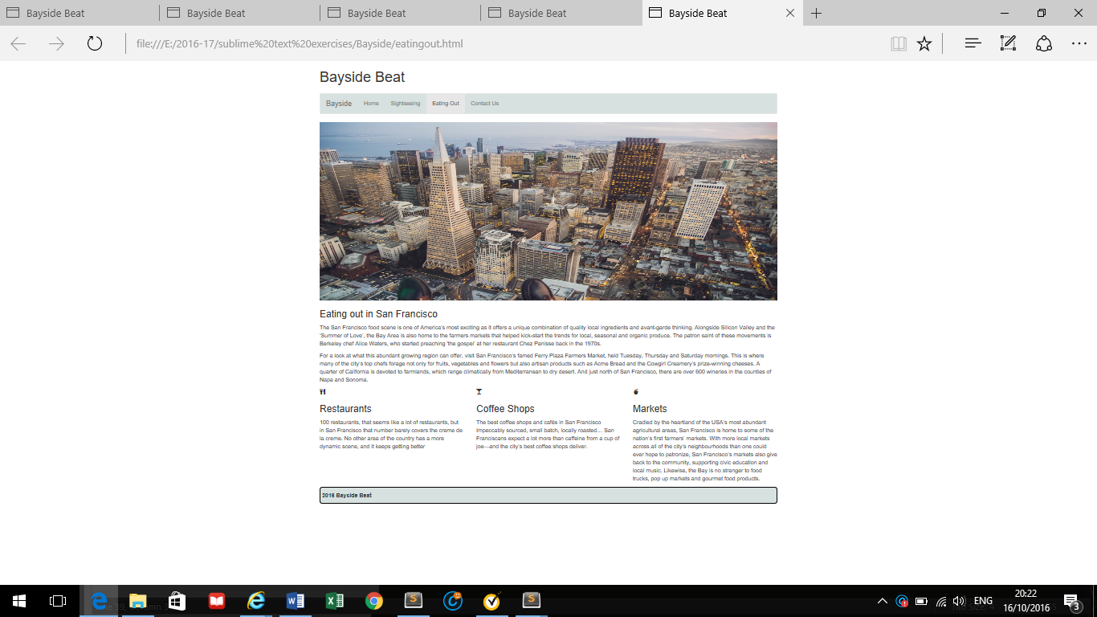

**Adding layout to the contactus.html page**

Make sure that the contactus.html page is open and after the code for the **image**, add the following code:

<div class="row">

<div class="col-sm-12">

<h3>Where to find San Francisco</h3>

<div class="map-responsive">

<iframe>

</iframe>

</div>

</div>

</div>

Inside the iframe the code for the map of San Francisco will be entered.

Go to Google maps and type San Francisco into the search bar

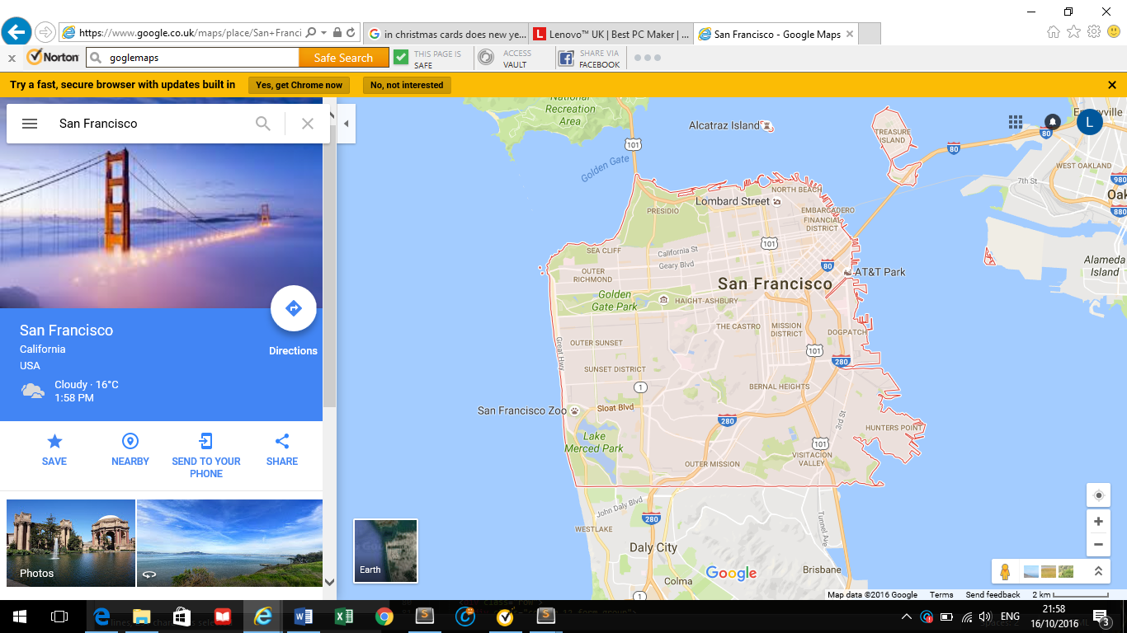

Click on the share link and the following box will be displayed.

Make sure the embed map and small options have been selected as shown

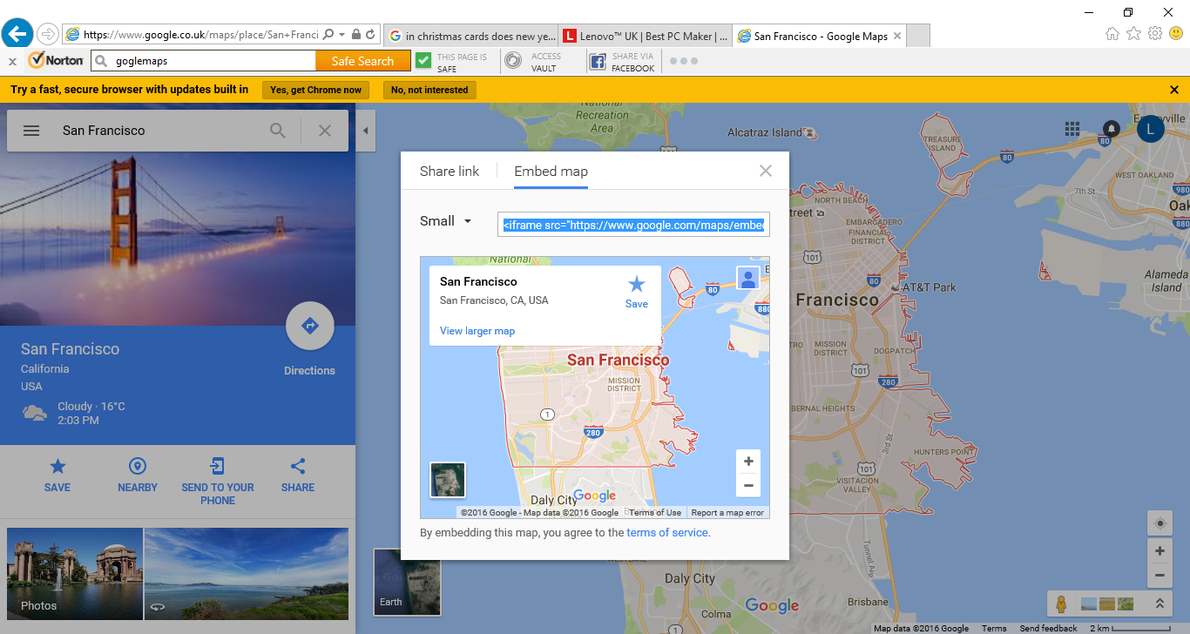

Copy the code and paste between the iframe tags. The code will look similar to the following:

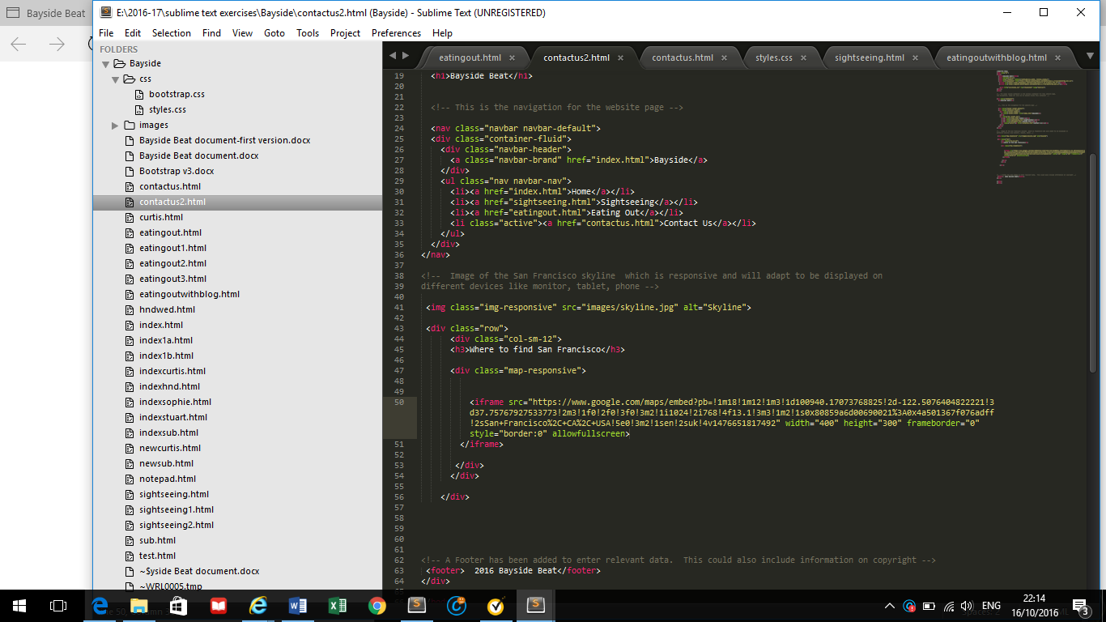

In the code, change the width to 100%

Save the page and preview in the browser

Insert the following comment after the code for the image so that it looks like the following:

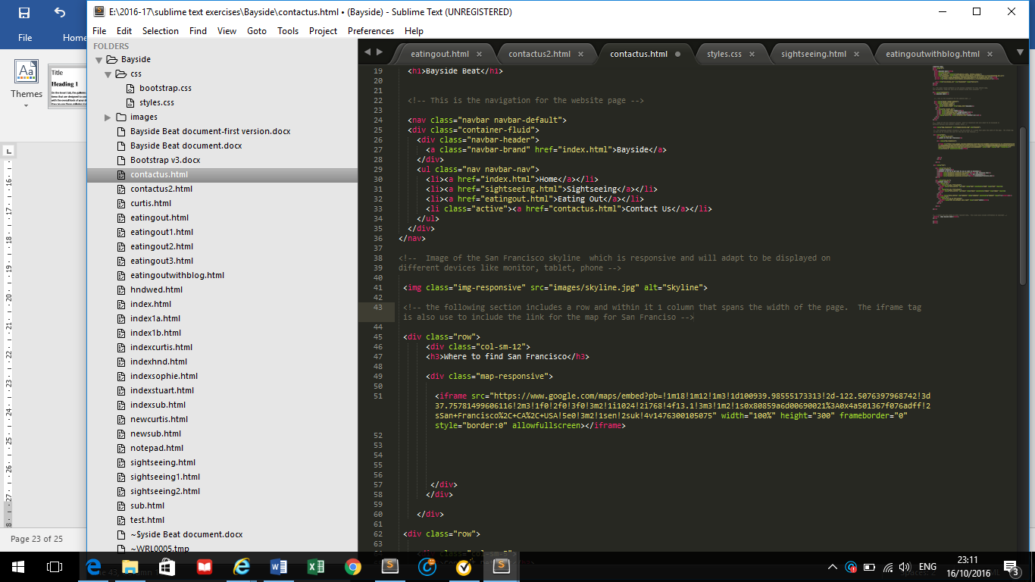

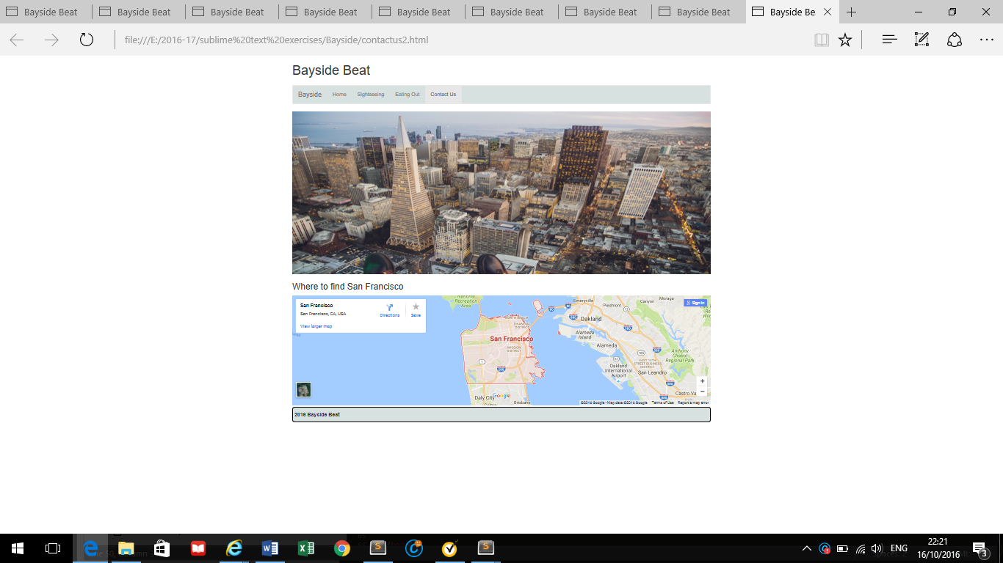

Next is adding the structure for the rest of the page. Copy the following code after the closing div for the section for the map

<div class="row">

<div class="col-sm-5">

<h3>Contact Details</h3>

<p>Contact us and we'll get back to you as soon as possible</p>

<p><span class="glyphicon glyphicon-map-marker"></span> San Francisco USA</p>

<p><span class="glyphicon glyphicon-phone"></span> +00 1515151515</p>

<p><span class="glyphicon glyphicon-envelope"></span> myemail@sanfrancisco.com</p>

</div>

<div class="col-sm-7">

<h3>Contact Form</h3>

<div class="row">

<div class="col-sm-6 form-group">

<input class="form-control" id="name" name="name" placeholder="Name" type="text" required>

</div>

<div class="col-sm-6 form-group">

<input class="form-control" id="email" name="email" placeholder="Email" type="email" required>

</div>

</div>

<textarea class="form-control" id="comments" name="comments" placeholder="Comment" rows="5"></textarea><br>

<div class="row">

<div class="col-sm-12 form-group">

<button class="btn btn-default pull-right" type="submit">Send</button>

</div>

</div>

</div>

</div>

Save the page and open in the browser

